Planning Worksheet for Inclusive & Equitable Teaching Online

With each issue of the Online Teaching Coaching Newsletter Summer Series, you’ll be provided with a planning worksheet so that you can apply the tips and best practices for inclusive & equitable teaching presented in the newsletter issue to your online course plans. In each planning worksheet, we suggest some best practices as possible examples for you to use in your online course. The list of examples is not exhaustive and we encourage you to try one or more of these examples when planning your course, or use them as a jumping off point for your own further research.

DESIGNING FOR ALL LEARNERS

Download this document to use it for your planning!

Reflect on your online course design and teaching and how you can use Universal Design for Learning (UDL) guidelines to address diverse learners. Use this worksheet to identify practices & plan activities that you already use or that you wish to explore to meet the needs for all online students.

Reflection Questions for Designing for All Learners
- Why is your course engaging to learners? This is the “Why” of UDL. Why should learners be interested in your course? Why should they persist in your course to achieve their goals?
- What content do your learners interact with in your course? This includes readings, text, images, and videos, audio? This is the “What” of UDL. What do learners experience in your course to achieve their goals?
- How does your course support learner action and expression? This is the “How” of UDL. How will students show their learning in your Blackboard course?
- How to check to make sure your Blackboard course content is accessible to all learners? What Mason resources are available to help you ensure accessibility?
Identify & Plan for Inclusive & Equitable Teaching Online

- Review the listed examples of best practices for UDL, and the accessibility & usability resources and checklist on the following pages. Then consider & plan various ways you may incorporate UDL, accessibility & usability into your online courses, guided by the basic principles of the UDL framework and of accessible course design.

How to Use Universal Design for Learning (UDL) to Create an Accessible, Inclusive and Equitable Online Blackboard Course for All Learners?

Students all come to our courses with myriad barriers to being academically successful, whether these stem from socio-economic factors, cultural/racial/gender differences, physical challenges such as hearing/vision impairment, neurodiversity, or being a Contemporary/First-Gen student. As instructors, we can choose to design, build, and teach our courses with intentional mindfulness toward equity, inclusion, and accessibility -- by incorporating the guidelines of Universal Design for Learning.
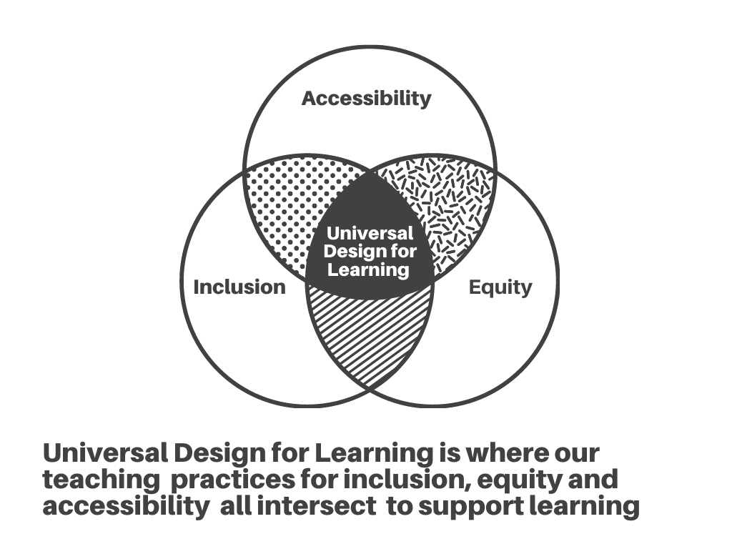
Figure 1: Universal Design for Learning and its relationship to practices for accessibility, inclusion, and equity. Based on information from CAST website (2018).

In this Planning Worksheet, we will share practices for how to make learning environments accessible and usable to all students applying principles of Universal Design for Learning (UDL) and accessible online course design. You’ll also find many of these practices detailed in the Stearns Center Digital Learning’s Quality Assurance Checklist and Guidelines for Online Courses (available by request from Stearns Center Digital Learning Quality Assurance Team).

We encourage you to use examples of practices for Universal Design for Learning to optimize learning for all your online students. Do this by following the three basic guidelines: Multiple Means of Engagement; Multiple Means of Representation; Multiple Means of Action and Expression.

For more information, download this handout about the UDL framework.

Examples of UDL Practices in Online Courses

- Provide multiple means of engagement. Engage students by optimizing relevance, value and authenticity. Allow students to meet learning outcomes and to personalize an assignment, with choices such as completing a paper, making a video, delivering a presentation, or creating an infographic.

- Keep students engaged and focused in your Blackboard course. Use clear and consistent Blackboard course organization, predictable structure, and easy navigation. Provide instructions and rubrics at multiple locations in the course, particularly at “point of need” (i.e., posted at submission point for assignment in Blackboard; posted in module for week in which assignment is due).

- Present content in multiple ways that are each designed in an accessible manner. Explain an important concept through a combination of text, video, audio, and/or images.

- Include representation of diversity in course content. Include content, images, and media that reflect diverse identities, especially reflecting the identities of your students.

- Provide multiple ways for students to demonstrate what they have learned. Instead of focusing on traditional tests and assessments, consider alternatives for demonstrating knowledge (e.g., group work, videos, demonstrations, portfolios, research papers, and presentations).

- Integrate multiple means of learning support into your course. Examples include: Ask Your Instructor Discussion forum; tutorials; assigning study buddies or study groups; connecting students with the Learning Services; inviting Mason Libraries and Writing Center for guest presentations and student consultations.

- Use mixed modalities (i.e., synchronous and asynchronous formats in Blackboard) for class to connect in office hours, consultations, course activities, etc.

- Create accessible documents and presentations. Learn how to use Blackboard Ally to check accessibility of all posted documents and images in your online course. Use Ally guidance to improve accessibility.

- Contact the Assistive Technology Initiative (ATI) Office to assist you with accessibility of your course design and materials, to make sure that there are no barriers in your course for all students, and particularly for use of assistive technologies.

Resources for Accessibility & Usability at Mason

Here we highlight three important resources available at Mason to ensure that your Blackboard course and content are accessible to all learners.

- Mason's Assistive Technology Initiative Office is a great resource for faculty to ensure their course content is accessible. ATI is committed to ensuring equivalent access to all information and communications technology resources on our campuses. Their services include training and technical assistance regarding the appropriate use of assistive technology, web compliance, document accessibility, and closed captioning and audio description for instructional video resources. Please contact the Assistive Technology Initiative at Mason (ati@gmu.edu) with any questions about accessibility for your online course.

- Blackboard Ally Tool. Since the fall 2020 semester, Blackboard Ally is an accessibility tool that has been made available in all online and/or hybrid Blackboard courses.

- For Instructors: Ally is an accessibility tool that is designed to help you build a more inclusive online learning environment and improve access to instructional resources. Ally assists you with identifying images, documents, and content in your Blackboard course site (or organization) that could be inaccessible to your students. Ally provides you feedback on the accessibility of your course files with the colored dials that appear next to your file names (Red, Orange, Light Green, and Dark Green). These indicators are only visible to you and other instructors with access to your course. When you click the indicator, Ally walks you through a series of steps to make the file more accessible. If you need help, you may contact ATI directly within Ally to request assistance. Learn more about Blackboard Ally for Instructors.

- For Students: Ally creates a more engaging and user-friendly experience by enabling student to select the alternate formats (e.g., electronic braille, PDFs, audio/MP3, etc.) that best support specific learning needs. Learn more about Blackboard Ally for Students.

- Mason CARES Guide. ATI has created the Mason CARES Guide, which stands for Creating Accessible RESources Guide. This resource provides guidance on:

- How to make your Blackboard course more accessible and usable.
- How to ensure multimedia (i.e., audio and/or video) used online is accessible.
- How to create accessible documents (i.e., Word, PPT, PDF).
- For more information, visit the Mason CARES Guide (on ATI website).

Blackboard Accessibility and Usability Checklist

(from Making your Blackboard Course Site Accessible and Usable, ATI website)

- Rename your Blackboard Course. Renaming your Blackboard course with a course title, instead of course ID string, is especially important for students who rely on text-to-speech or screen readers to locate courses.

- Use “Start Here” or “Welcome” Links. Creating a Start Here or Welcome page provides students with clear guidance on how to get started working with your online course.

- Include “How to Get Started” Video. Include a short video introduction acclimating students to the course site and how best to access instructional resources and assignments.

- Include Captions or Transcripts for Multimedia. All videos should have accurate, synchronized closed captions. All audio content should include a transcript. For videos where the visual imagery is a critical part of the instruction, audio description should be included as well. Contact ATI to request captioning or transcripts for videos.

- Include Headers for Content Areas. Headers provide critical structure in your Blackboard course; chunking content so that students who use screen reading applications can navigate to specific content areas.

- Identify Table Column Headers. Table headers allow screen reading applications to associate the data in a table cell with the respective column header.

- Add Alternative Text Descriptions for Complex Images. It is important to provide alternative text descriptions for any content where the visual imagery is critical to understanding its meaning.

- Use Meaningful Hyperlink Text. Hyperlinks should inform users where clicking the link will actually take them. For example, create descriptive links such as “Learn more about (topic)”. Avoid URLs and non-specific references like “click here” or “read more”.

- Use Good Color Contrast. Ensure your web text colors have the appropriate color contrast by using the WEBAIM Contrast Checker.

- Hide Unused Tools in the Blackboard Tools Menu. Hiding unused tools in your course reduces cognitive load and allows students to focus on relevant content.
Learn More about UDL and Accessibility

- CAST (2018). Universal Design for Learning Guidelines version 2.2.

- Bass, G. and Lawrence-Riddell, M. (2020, January 6). UDL: A powerful framework. Faculty Focus, Magna Publications.

- Howard, C. (2020, March 4). Designing for accessibility: How to front-load your digital content with UDL principles. Faculty Focus, Magna Publications.

Links to Mason Resources

- Assistive Technology Initiative, George Mason University.
  - Blackboard Ally for Instructors
  - Creating Accessible RESources Guide (CARES Guide)

- Stearns Center for Teaching & Learning, George Mason University.
  - Accessibility for All Learners
  - Creating Inclusive Classroom.

- Make sure to regularly check Stearns Center website for online teaching resources, upcoming webinars & workshops, and for continuing professional development for teaching!

Contact Us!
Office of Digital Learning | Stearns Center for Teaching and Learning
Phone: 703-993-6200 | Email: stearns@gmu.edu
Suite 412 Innovation Hall, Fairfax Campus
George Mason University
MY PLANNING NOTES

