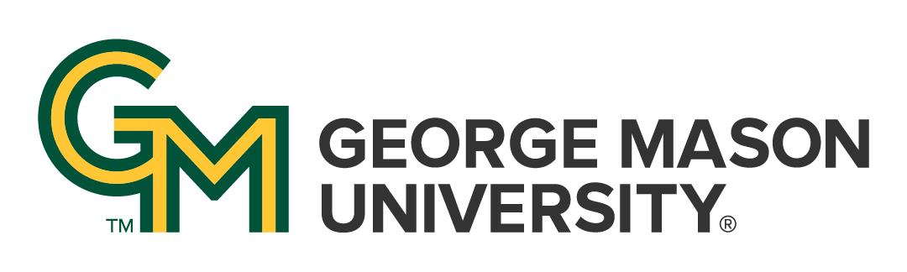

# Common Policies Affecting All Courses at George Mason University

**Updated August 2025**

These four policies affect students in all courses at George Mason University. This Course Policy Addendum must be made available to students in all courses (see [Catalog Policy AP.2.5](https://catalog.gmu.edu/policies/academic/course-information/#AP-2-5)).

**Additional policies** affecting this course, and additional resources or guidance regarding these policies, may be provided to students by the instructor.

## Academic Standards

Academic Standards exist to promote authentic scholarship, support the institution’s goal of maintaining high standards of academic excellence, and encourage continued ethical behavior of faculty and students to cultivate an educational community which values integrity and produces graduates who carry this commitment forward into professional practice.

As members of the George Mason University community, we are committed to fostering an environment of trust, respect, and scholarly excellence. Our academic standards are the foundation of this commitment, guiding our behavior and interactions within this academic community. The practices for implementing these standards adapt to modern practices, disciplinary contexts, and technological advancements. Our standards are embodied in our courses, policies, and scholarship, and are upheld in the following principles:

* **Honesty:** Providing accurate information in all academic endeavors, including communications, assignments, and examinations.
* **Acknowledgement:** Giving proper credit for all contributions to one’s work. This involves the use of accurate citations and references for any ideas, words, or materials created by others in the style appropriate to the discipline. It also includes acknowledging shared authorship in group projects, co-authored pieces, and project reports.
* **Uniqueness of Work:** Ensuring that all submitted work is the result of one’s own effort and is original, including free from self-plagiarism. This principle extends to written assignments, code, presentations, exams, and all other forms of academic work.

Violations of these standards—including but not limited to plagiarism, fabrication, and cheating—are taken seriously and will be addressed in accordance with university policies. The process for reporting, investigating, and adjudicating violations is outlined in the university’s [academic standards procedures](https://academicstandards.gmu.edu/). Consequences of violations may include academic sanctions, disciplinary actions, and other measures necessary to uphold the integrity of our academic community.

The principles outlined in these academic standards reflect our collective commitment to upholding the highest standards of honesty, acknowledgement, and uniqueness of work. By adhering to these principles, we ensure the continued excellence and integrity of George Mason University's academic community.

**Student responsibility:** Students are responsible for understanding how these general expectations regarding academic standards apply to each course, assignment, or exam they participate in; students should ask their instructor for clarification on any aspect that is not clear to them*.*

## Accommodations for Students with Disabilities

Disability Services at George Mason University is committed to upholding the letter and spirit of the laws that ensure equal treatment of people with disabilities. Under the administration of University Life, Disability Services implements and coordinates reasonable accommodations and disability-related services that afford equal access to university programs and activities. Students can begin the registration process with Disability Services at any time during their enrollment at George Mason University. If you are seeking accommodations, please visit the [Disability Services website](https://ds.gmu.edu/) for detailed information about the Disability Services registration process. Disability Services is located in Student Union Building I (SUB I), Suite 2500. Email: [ods@gmu.edu](mailto:ods@gmu.edu). Phone: (703) 993-2474.

**Student responsibility**: Students are responsible for registering with Disability Services and communicating about their approved accommodations with their instructor *in advance* of any relevant class meeting, assignment, or exam.

## FERPA and Use of GMU Email Addresses for Course Communication

The [Family Educational Rights and Privacy Act (FERPA)](https://studentprivacy.ed.gov/ferpa) governs the disclosure of [education records for eligible students](https://registrar.gmu.edu/ferpa/) and is an essential aspect of any course. **Students must use their GMU email account** to receive important University information, including communications related to this class. Instructors will not respond to messages sent from or send messages regarding course content to a non-GMU email address.

**Student responsibility**: Students are responsible for checking their GMU email regularly for course-related information, and/or ensuring that GMU email messages are forwarded to an account they do check.

## Title IX Resources and Required Reporting

As a part of George Mason University’s commitment to providing a safe and non-discriminatory learning, living, and working environment for all members of the University community, the University does not discriminate on the basis of sex or gender in any of its education or employment programs and activities. Accordingly, **all   
non-confidential employees, including your faculty member, have a legal requirement to report to the Title IX Coordinator, all relevant details obtained directly or indirectly about any incident of Prohibited Conduct** (such as sexual harassment, sexual assault, gender-based stalking, dating/domestic violence). Upon notifying the Title IX Coordinator of possible Prohibited Conduct, the Title IX Coordinator will assess the report and determine if outreach is required. If outreach is required, the individual the report is about (the “Complainant”) will receive a communication, likely in the form of an email, offering that person the option to meet with a representative of the Title IX office.

For more information about non-confidential employees, resources, and Prohibited Conduct, please see [University Policy 1202](https://universitypolicy.gmu.edu/policies/sexual-harassment-policy/): Sexual and Gender-Based Misconduct and Other Forms of Interpersonal Violence. Questions regarding Title IX can be directed to the Title IX Coordinator via email to [TitleIX@gmu.edu](mailto:TitleIX@gmu.edu), by phone at 703-993-8730, or in person on the Fairfax campus in Aquia 373.

**Student opportunity**:  If you prefer to speak to someone ***confidentially***, please contact one of Mason’s confidential employees in [Student Support and Advocacy](https://ssac.gmu.edu/) (SSAC), [Counseling and Psychological Services](https://caps.gmu.edu/) (CAPS), [Student Health Services](https://shs.gmu.edu/) (SHS), and/or the [Office of the University Ombudsperson](https://ombuds.gmu.edu/).